Name : Prajwal Weladi

Class : CSAI-A

Roll no. : 53

Prn. : 12210360

**Lab Assignment 3**

**Basic Shell Programming**

1. Write a shell script program to execute ls, date and echo commands repeatedly.

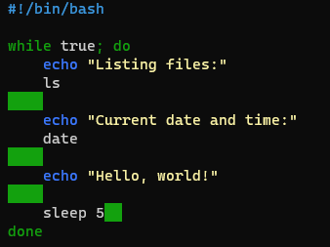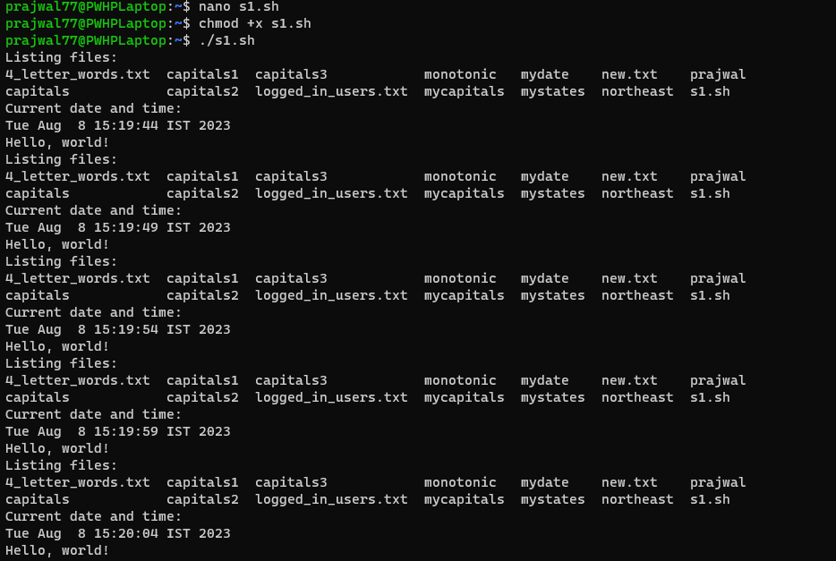

1. Write a shell script program to show the details related to shell, path and home directories of the user.

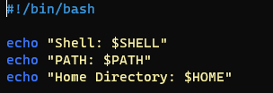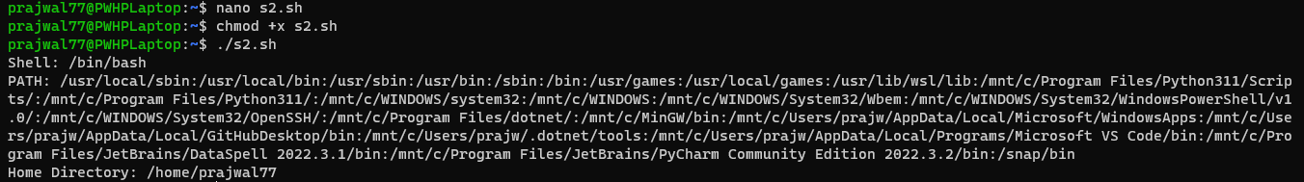

1. Write a shell script program to create two files. The name of the files will be passed by user using read function.

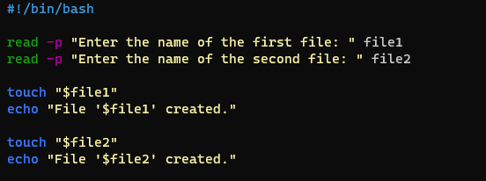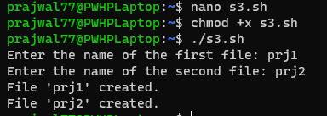

4. Write a shell script program to create two files. The name of the files will be passed by user using command line arguments.

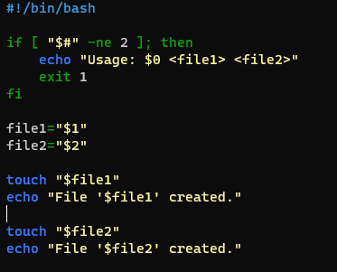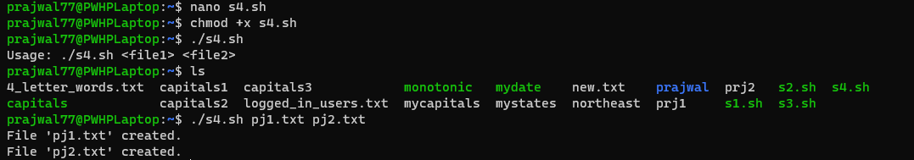

5. Write a shell script program to create two directories. The name of the files will be passed by user using read function.

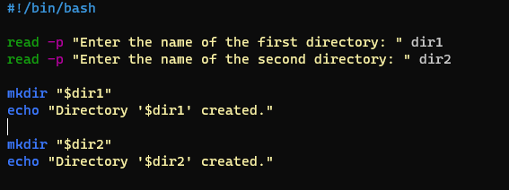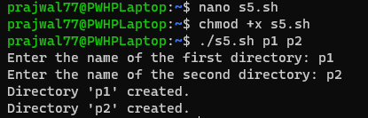

6. Write a shell script program to create two directories. The name of the files will be passed by user using command line arguments.

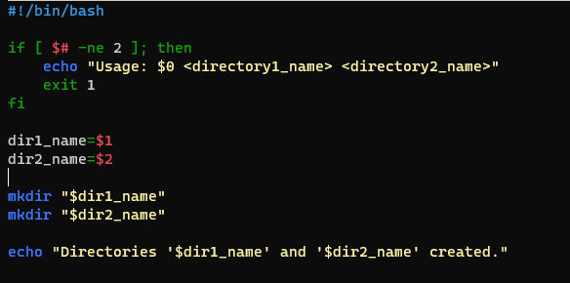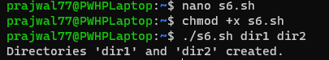

7. Write shell script to change the name of a file .Ask from user old filename and new filename.

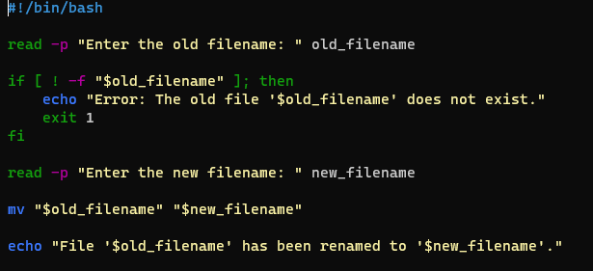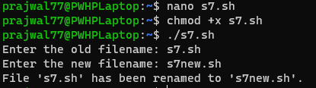

8. Write a shell script to find the largest number among three numbers.

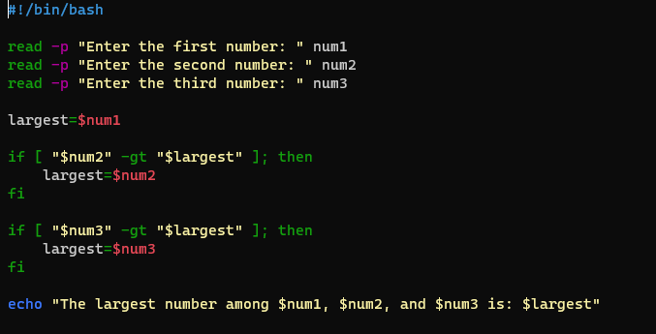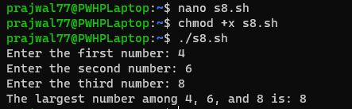

9. Write shell script to create three files f1, f2, f3 using for loop.

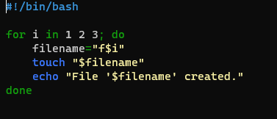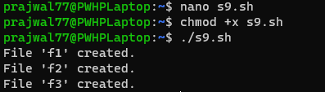

10. Write a shell script to display date and time. Assume 1 sec delay.

